Verify login with invalid Data

(User Name)

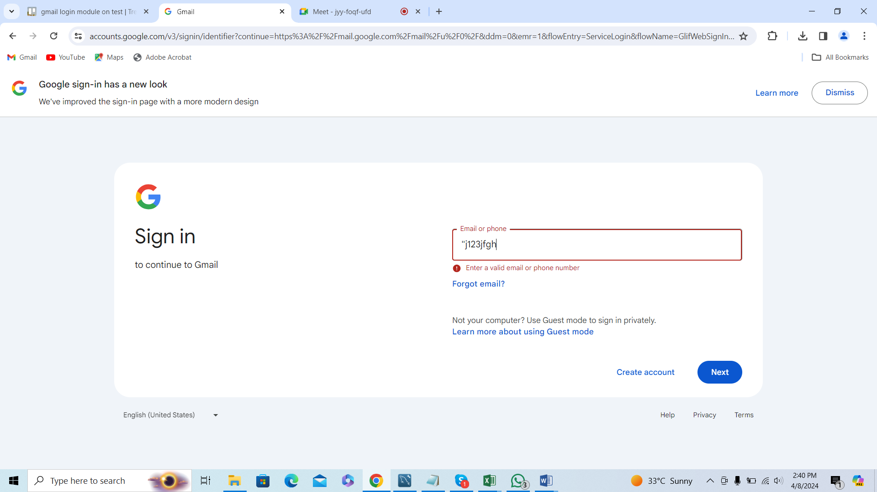

Error message is displayed